**Assignment 6 (SVM) for INF 552**

2016 fall

Yi Ren & Yiming Liu

**Part 1, Implementation**

1. language: Python 2.7
2. data structure: (1).X: numpy.mat, (2).Y:list , (3).dictionary,
3. logic:

(1). First: Quadiatic Programing(optimal aierfa), using package(cvxopt)

Minimize:

$$L\left(α\right)=\frac{1}{2}α^{T}Qα+{\left(-1\right)}^{T}α (4)$$

Such that

$$α_{n}≥0 -constraint (1)$$

$$\sum_{n=1}^{N}{α_{n}}y_{n}=0 -constraint (2)$$

(2). Second: get weights:

$$W= \sum_{n=1}^{N}{α_{n}}{y_{n}X}_{n}$$

(3). Figure out b and support vectors

1. result:

(1). Linsep.txt:

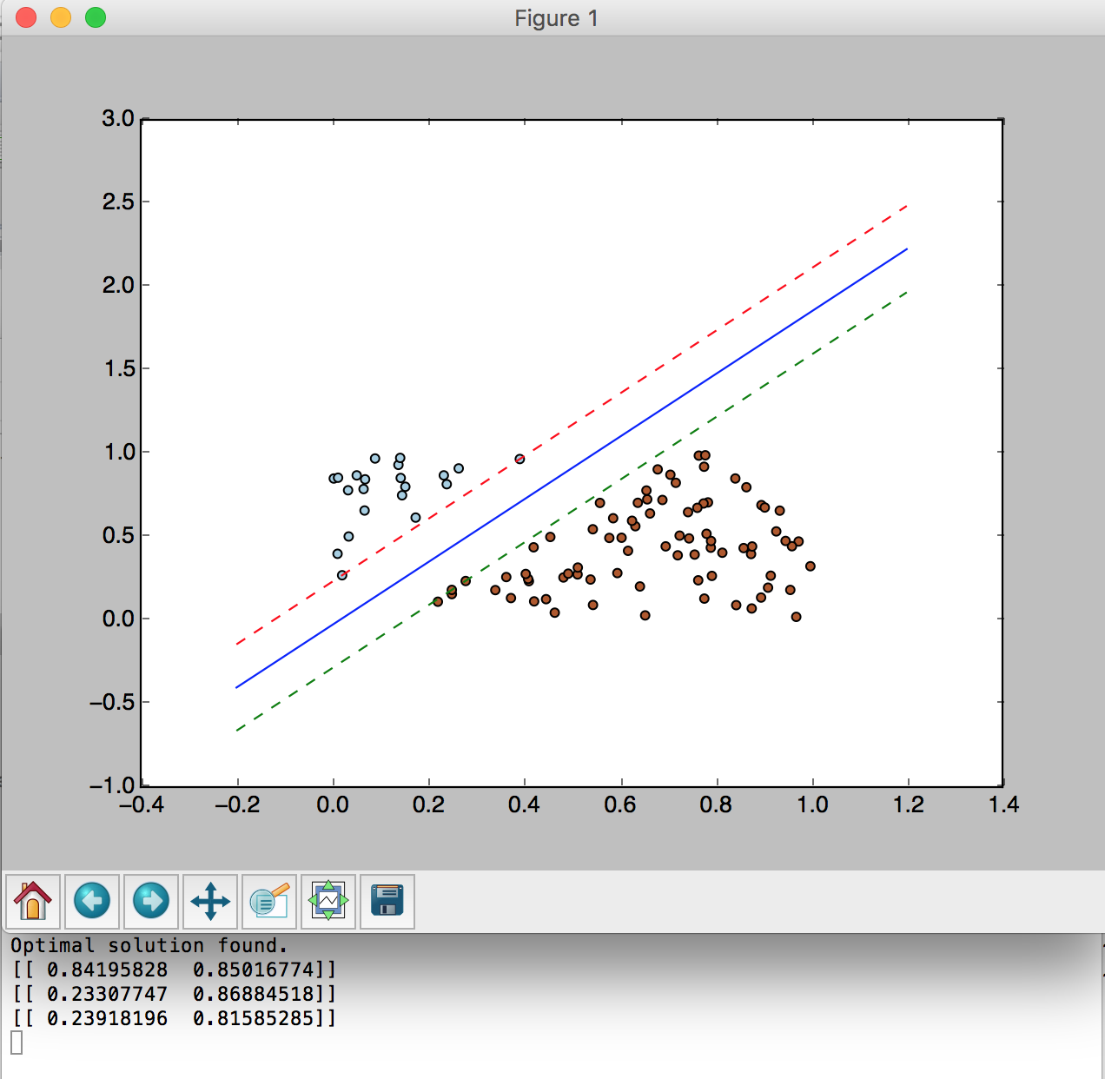

(2). Nonlinsep.txt

overall:

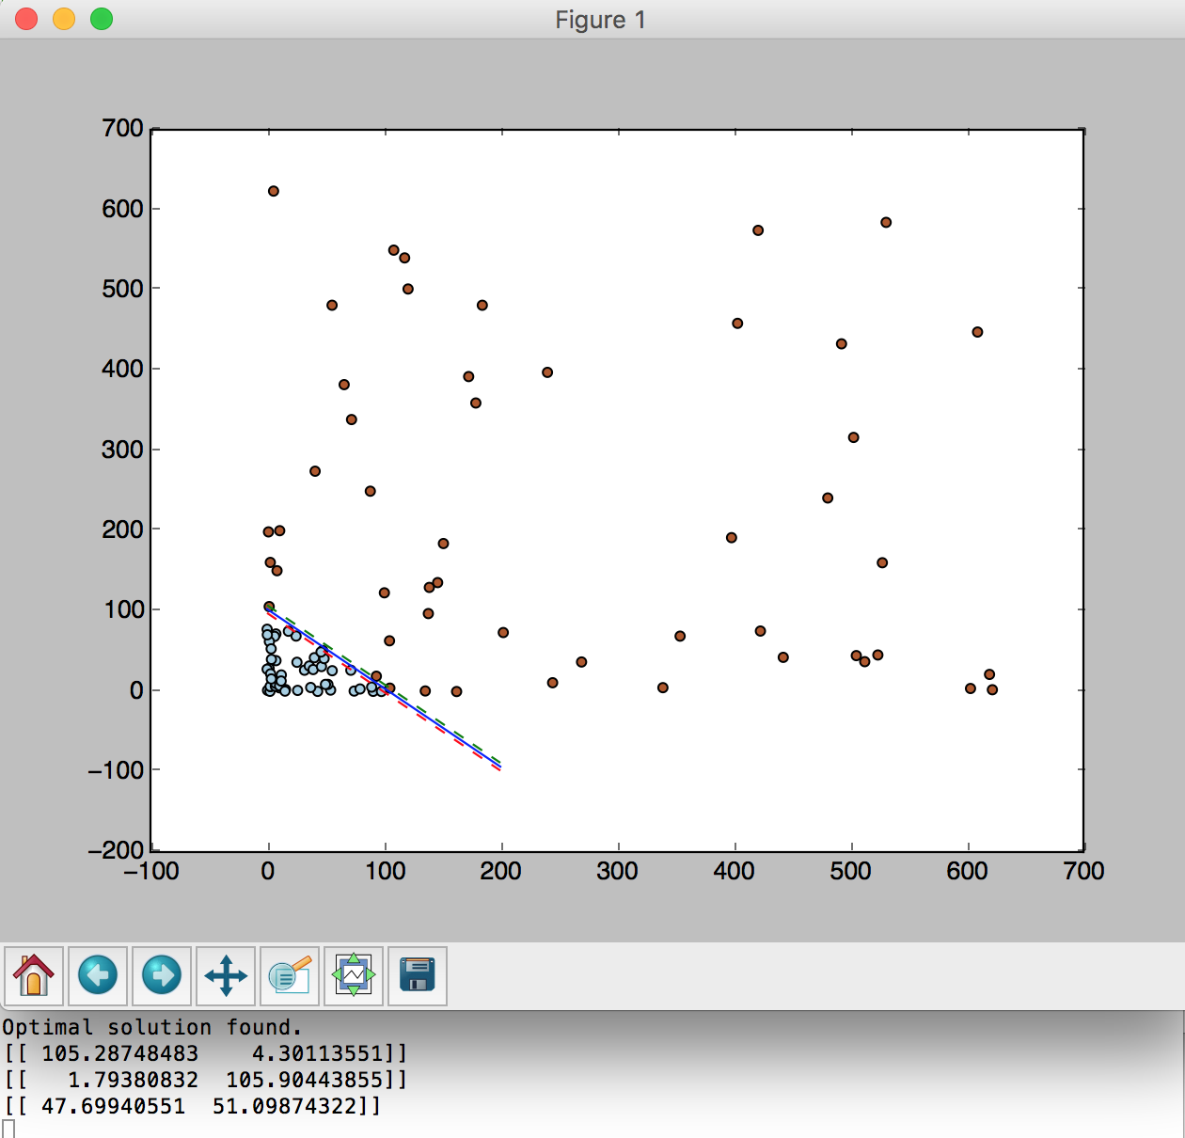

detail:

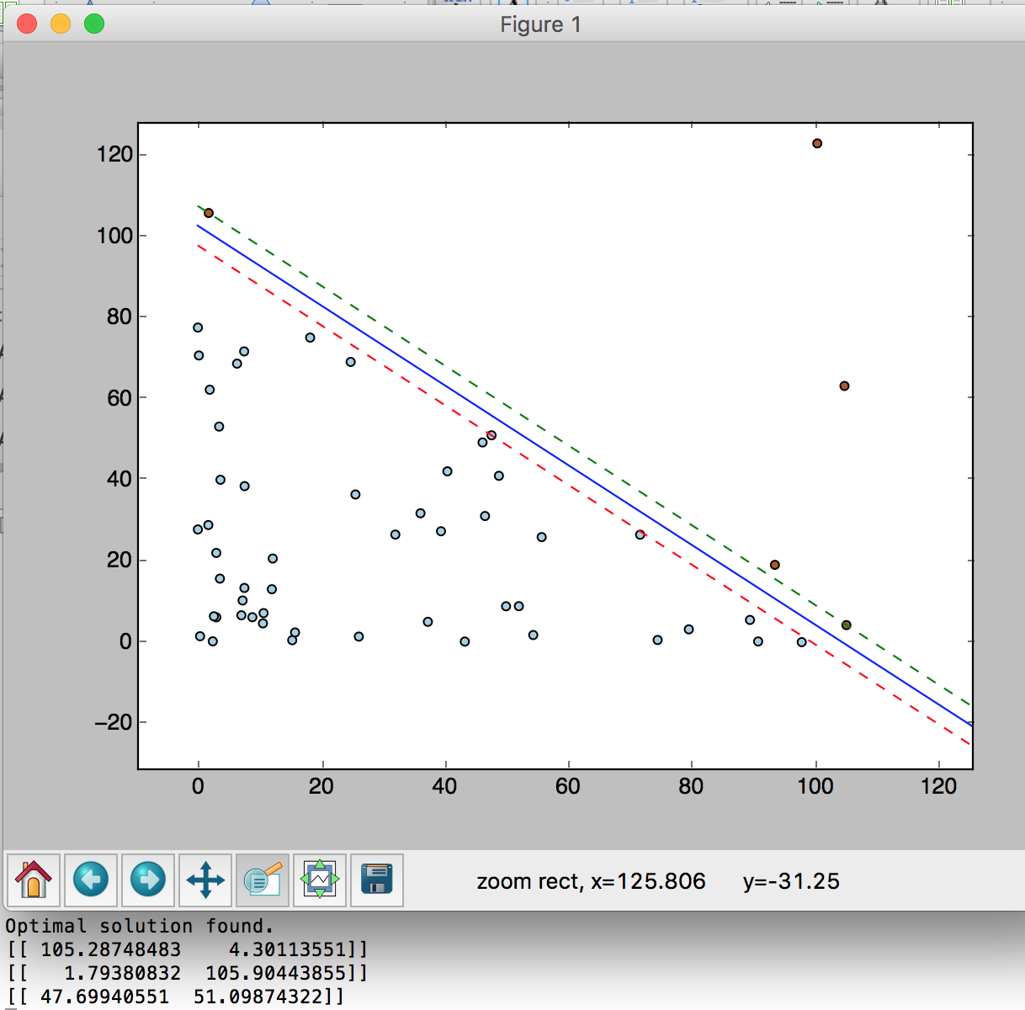

Part 2: Software Familiarization

Sklearn is a good package for SVM, here is the result of SVM using sklearn:

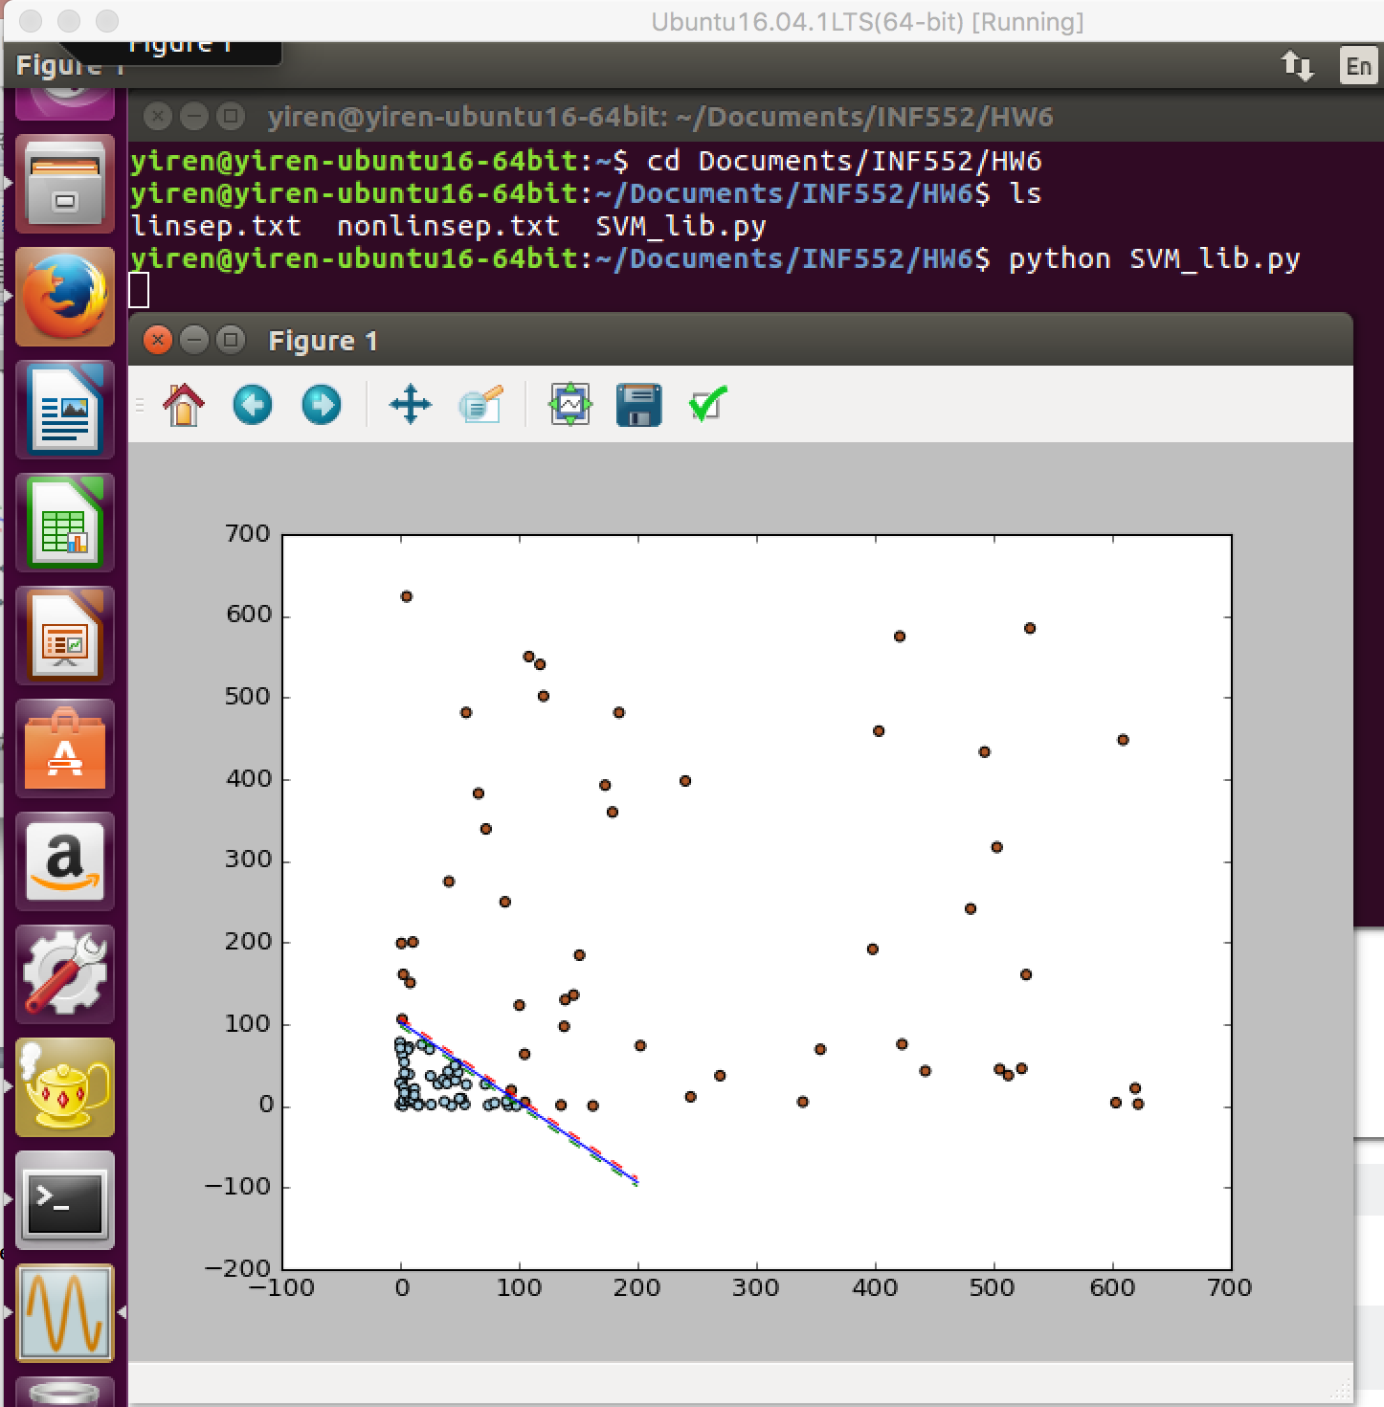

compare: the result is very similar.

**Part 3, Applications:**

SVM has been used successfully in many real-world problems[1].

(1). text (and hypertext) categorization

* + The classification of natural text (or hypertext) documents into a fixed number of predefined categories based on their content, e.g. email filtering, web searching, sorting documents by topic, etc..
  + A document can be assigned to more than one category, so this can be viewed as a series of binary classification problems, one for each category

(2). image classification

(3). bioinformatics (Protein classification, Cancer classification)

(4). hand-written character recognition

reference:

[1] Support Vector Machine & Its Applications **Mingyue Tan**, The University of British Columbia, Nov 26, 2004

Division of Work

Both members wrote the program to verify the accuracy of each others' code, and finish this report together.